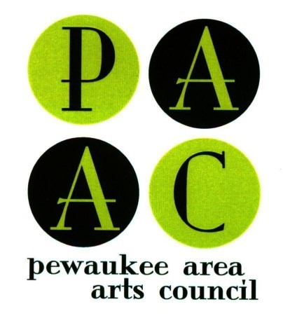
ENTRY FORM
Plein Air Painting Competition

Pewaukee Boat Show
Saturday August 22, 2020

- - - - - - Please Print - - - - -

NAME:______________________________________________________________

ADDRESS:___________________________________________________________

CITY:__________________________________ STATE:________ ZIP:___________

CELL PHONE:_______________________E-MAIL ____________________________
(on which we can reach you the day of the event)
Check here if this is the first Plein Air competition you have ever entered. _________

□ Entry Fee post marked by July 15 is $25
□ Late or day-of- entrants entry fee is $35

Mail to: PAAC Plein Air Art Competition
C/O Barbara Kelsey
355 Stone Ct.
Pewaukee, WI 53072

Check-in: Saturday August 22, 2020 from 8:00am – 10am (at PAAC tent)

If my painting sells, Pewaukee Area Arts Council will retain 35% of the selling price for commission, and I will receive 65% by check within two weeks of the event.

As a condition of my participation in the PAAC Plein Air Painting Competition, I agree to bear all risk and expense for any loss, theft or damage to my paintings or other personal property or injury to my person, regardless of cause; and to abide by all rules specified in the Event Rules. I indemnify and hold harmless the Pewaukee Area Arts Council, and the Pewaukee Boat Show from and against any claim, suit, action, liability or expense arising out of any matter that would result from exhibiting or using images of my paintings for publicity. PAAC reserves the right to accept or not accept any painting for exhibition. The participating artists and all paintings submitted may be photographed and/or video-taped by PAAC for promotional purposes.

_____ Initial if you will allow PAAC to use images of your 2020 competition painting(s) solely to benefit the ARTs through the Pewaukee Area Arts Council.

____________________________________________________________ __________________
(Signature) (Date)

